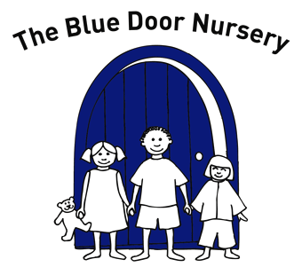
The Blue Door Nursery
Enrolment form
Please ensure that you give as much detail about your child as possible, if you would prefer to fill in the form in discussion with a Nursery manager then please ask – it won’t be a problem!
Child’s full name (as it appears on the birth certificate)
Child’s date of birth:

Child’s known name (if different to above)

Child’s first language

Address:

Postcode:

Home telephone:

Contact numbers during sessions:

Name of Parents / Carers with whom the child normally lives:

Do all the above have parental responsibility for the child? YES / NO

Any other adults with parental responsibility / rights with whom the child does not live?
Name:
Address:

Telephone number:
Relationship to child?

Is this person an emergency contact? YES / NO

Please provide details of two people who can act in an emergency for your child:
Name:
Contact number:
Relationship to child:

Name:
Contact number:
Relationship to child:

In the event that no one can be contacted in an emergency the Nursery Manager will allow other trained professionals to make decisions in the best interest of your child (e.g. medical staff).

Child’s doctor:
Surgery name and address:

Telephone number:

Child’s Health visitor:
Telephone number:

Has your child any medical condition we should be aware of? (Asthma, eczema etc)

Has your child any allergies, food intolerances etc

If yes, how does your child react to these? (So that we know the symptoms to look for in cases of emergency)

Are there any special dietary needs or preferences?
Does your child have any other special needs and / or need any additional support?

Are there any other professionals involved with your child? E.g. Social services, Speech therapy etc

Permissions
I give consent for photographs to be taken of my child for display, records keeping purposes: YES / NO

I understand that if the Nursery wants to use photographs of my child for advertising purposes (E.g. on the Nursery website) I will be asked for separate permission for each photograph: YES / NO

I give consent for staff and other agencies such as Ofsted, Area Senco, and Health Visitors to carry out and record observations of my child for the purpose of developmental assessment: YES / NO

I give consent for my child to be taken off site for short walks or to the park as part of Nursery activities. I understand that any offsite walk will have a ratio of 1 adult to 2 children: YES / NO

I give consent for the Nursery to act in the best interests of my child in the event of a medical emergency: YES / NO

I give consent for the Nursery to apply sun cream to my child YES / NO

I understand the terms and conditions as they have been explained to me and I wish to apply for a place at The Blue Door Nursery for:
I enclose a deposit of I understand that the deposit will not be returned if the place is not taken up. In all other circumstances the deposit will be applied to your child’s closing invoice.
Signed: Date

Day of the week | Session start time | Session finish time
Monday

Tuesday

Wednesday

Thursday

Friday

The following documents should also have been given to you:
- A copy of the Nursery financial terms and conditions
- Immunisation, vaccination and medical details form (please fill this in and return it to us as soon as possible)
- A medical details form if your child is on regular medication at home (please fill this in and return to us)
- An ‘All about me booklet’ please fill this in (with your child if appropriate) and return it to us)
- A copy of the most recent nursery newsletter and information sheet
- A copy of the Nursery’s responsibilities regarding Fair Processing
- A copy of the Nursery’s responsibilities regarding Child Protection
It should also have been explained out to you:
- What the Nursery’s medication policy says
- Where the parents information board is
- Where fees are paid
- Where the Nursery policies and procedures are kept
- Where your child’s things will be kept while at Nursery
- How to make comments and suggestions about the Nursery
- How to complain if there is something you are not happy with
If you haven’t had any of these please ask for them, thank you

